This is my scripting language called DM++ Script I bet some of you remember this from years ago. Well since then 2 weeks ago I decided to begin the project from scratch and this time has a lot more stuff in it

Well I hope you find it useful and may help in your own projects.

Compiling the project.
Now this project comes in two parts First it is the IDE, then the DM++ Script framework
To get the IDE to work it is required to have the framework installed.

Compiling the IDE open up the project file IDE.vbp and click File-> make compile to an exe for now compile to the folder were you’re reading this file.

Ok compiling the framework next open the folder \Framework\CompileMe.vbg

Note CompileMe.vbg is a group file that you can use to compile all the framework components

Now click File-Make Project Group

Ok testing that all files have been compiled. open up the folder \Framework\v1.0\

The contents should look like the one below:

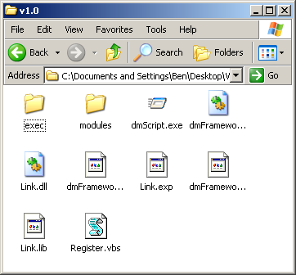
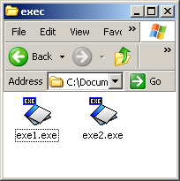

In the Exec folder you should have two exe files:

exe1.exe
exe2.exe

If your folders do not look like mine you will have to open up each project and do a manual compile.

Ok a quick look over the files.

Exec\ folder as you may have already guessed is for compiling the scripts to an exe file, There are two types a framework application and a standalone application. See IDE Compiling for more info

Modules\ folder contains all the modules used by DM++ it’s own language. Just think of them as you would think of include files in C++
DmScript.exe this is the application that allows you to run DM++ scripts from windows by double clicking on them like in VbScript

Link.dll used by the IDE for compiling the scripts.

DmFramework.dll the main component of the DM++ Language Runtime

Register.vbs this is used to register all the components for the DM++ Language, this includes adding the file type to the registry

The rest of the files are temp files that VB creates delete them if you want.

Ok before we get started you may want to move the files to a place on your PC I did this as it makes things easier.

So what I did was

Create a new folder on my C: drive called dmScript then copy the folder above and all it contents to \dmScript\ v1.0

Ok that about it now run in C:\dmScript\v1.0\Register.vbs

Note you may need to reset your PC after running the register.vbs for the icon to show on the scripts.

If all goes well double click on a script example they are in the IDE folder\scripts\ and it should work.

Before I go just like to tell you I left a small help file in the IDE gives you some information on the Language. The IDE also have a built in reference of most of the functions available.

Any problems email me vbdream2k@yahoo.com

O I will have a web-site for this soon but at the moment I awaiting for the activation of one of them Free redirection URLS think thy said be about 5 days. So anyway I left the URL down below for you.

http://www.dmeasyhttp.2ya.com

if it is not there it will also be on my other web-site http://www.eraystudios.co.uk/dmscript

I hope to have the website sorted out in the next 2 days or so. Other than that You see an update on pscode ☺

